Project
Project on Home Automation System

By
Md. Tasriful Hoque Mozumder
ID: CSE 06607652

Supervised By
Tarikuzzaman Emon
Assistant Professor of
Department of Computer Science and Engineering
Stamford University Bangladesh


Stamford University Bangladesh

CONTENTS

CHAPTER PAGES
- Introduction …………………. 1
- Literature review ………………… 4
- Project Management …………… 9
- Technical Specifications………... 14
- Risk Management ………………. 22
- Conclusion ………………………. 25

CHAPTER ONE: INTRODUCTION

  - Introduction:

Home automation is an automation of home, house work or household activity. In other work, it gives an opportunity to use of computer to control panel infections. For example, it includes centralized control of lighting infections. It can include centralized control of lighting application security lack of gates and doors to supply flourish benefit case energy ability and security.

In present world, home automation is being popular due to comfort ability flexible means of monitoring and controlling the infections and other things according to users comfort and needs. The challenging part lies in simplify and cost of installing them in home and various with increasing number of services to be monitored and controlled. The project named “Home Automation” is concept of home automation using android phone. The popularity of home automation has been rising comprehensively due to considerable capability and ease through android phone and tablet connectivity. A home automation system integrates electrical devices with one another. The technique applied in home automation include those in building automation and the control of house old activities such as lighting control system and the use of other electrical appliance devices may be connected via a home network to offer the restraint by a pc and may permit remote access from the internet. Through the integration of information technologies with the home environment, method and appliance can be connected in as mobilized process which results in convenience power efficiency and security benefits.

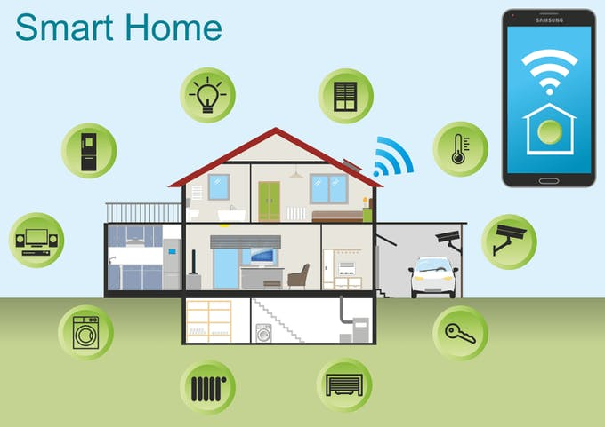

Figure 1.1: Home Automation System
  - Problem Statement

There is a large energy exigency within the present situation of our country. Moreover, people become negligent in proper utilization of available energy. People often forget to turn of the light sources and home appliance while getting out from home. Even in those situation, application of home automation makes it possible to control them from a distant place in easy way with our smartphone.
People are early and late running from place to place, working to accomplish everything on our never ending to-do list. Because of the HA system. We never have to take tension about opening the door, switching off the appliances and so on. In short we can save valuable time and experiences more daily productivity.

  - Objectives

The main objectives of our object are as follows:
1. To remotely control home appliances and monitor them.
2. To save the time and utilize the energy efficiently.

  - Applications

The application include remote controlling of home appliances and lighting systems in an easy. Also home security and monitoring can be achieved.

  - Project Features

The features of our project can be highlighted in following point:

1. Remote control of home appliance from anywhere using app.
2. Continuous restraining and security of home with camera module.
3. Considerable reduction in
4. Mobile controlled fan (CPU fan)
5. Mobile controlled LED light
6. Gas alarm
7. Fire alarm

  - Hardware Requirements

Control electronics
1. Arduino Uno
2. Bluetooth module
3. PIR sensor
4. Servo motor
5. Bread board
6. Smoke detector
7. Buzzer
8. LED
9. DC fan

  - Software Requirements

1. Android development tools (ADT)
To build the android application to send the control signal to control the HA
Way and to receive the live video feed from the camera.

2. IDLE
-IDLE for python programming used to code the server side program.

3. RPI-GPIO library
-GPIO interface library for the aprotic Pi.

CHAPTER TWO: LITERATURE REVIEW

2.1 Introduction

Home automation is anything that enables you to use your home's lighting, heating and appliances more conveniently and efficiently. It can be as simple as remote or automatic control of a few lights, or it can be a complete system that controls all major parts of your home, custom set to your own personal preference.

Figure 2.1 Introduction of HA control by Smartphone

2.2 Related Works

Home automation gives you access to control devices in your home from a mobile device anywhere in the world. The term may be used for isolated programmable devices, like thermostats and sprinkler systems, but home automation more accurately describes homes in which nearly everything -- lights, appliances, electrical outlets, heating and cooling systems -- are hooked up to a remotely controllable network. From a home security perspective, this also includes your alarm system, and all of the doors, windows, locks, smoke detectors, surveillance cameras and any other sensors that are linked to it.

2.2.1 Home Automation Developments

Until fairly recently, automated central control of building-wide systems was found only in larger commercial buildings and expensive homes. Typically involving only lighting, heating and cooling systems, building automation rarely provided more than basic control, monitoring and scheduling functions and was accessible only from specific control points within the building itself.
Home automation is a step toward what is referred to as the "Internet of Things," in which everything has an assigned IP address, and can be monitored and accessed remotely.
The first and most obvious beneficiaries of this approach are "smart" devices and appliances that can be connected to a local area network, via Ethernet or Wi-Fi. However, electrical systems and even individual points, like light switches and electrical outlets, were also integrated into home automation networks, and businesses have even explored the potential of IP-based inventory tracking. Although the day is still far off when you'll be able to use your mobile browser to track down a lost sock, home networks are capable of including an increasing number of devices and systems.

2.2.2 Automation

Automation is, unsurprisingly, one of the two main characteristics of home automation. Automation refers to the ability to program and schedule events for the devices on the network. The programming may include time-related commands, such as having your lights turn on or off at specific times each day. It can also include non-scheduled events, such as turning on all the lights in your home when your security system alarm is triggered.
Once you start to understand the possibilities of home automation scheduling, you can come up with any number of useful and creative solutions to make your life better. Is that west-facing window letting in too much light? Plug your motorized blinds into a "smart" outlet and program it to close at noon each day. Do you have someone come by at the same time each day to walk the dog? Program your home automation system to unlock the front door for them, and lock it up again when they're done.

2.2.3 Remote Control

The other main characteristic of cutting-edge home automation is remote monitoring and access. While a limited amount of one-way remote monitoring has been possible for some time, it's only since the rise in smartphones and tablets that we've had the ability to truly connect to our home networks while we're away. With the right home automation system, you can use any Internet-connected device to view and control the system itself and any attached devices.
Even simple notifications can be used to perform many important tasks. You can program your system to send you a text message or email whenever your security system registers a potential problem, from severe weather alerts to motion detector warnings to fire alarms. You can also get notified for more mundane events, such as programming your "smart" front door lock to let you know when your child returns home from school. Show the figure 2.2 in Remote control home.

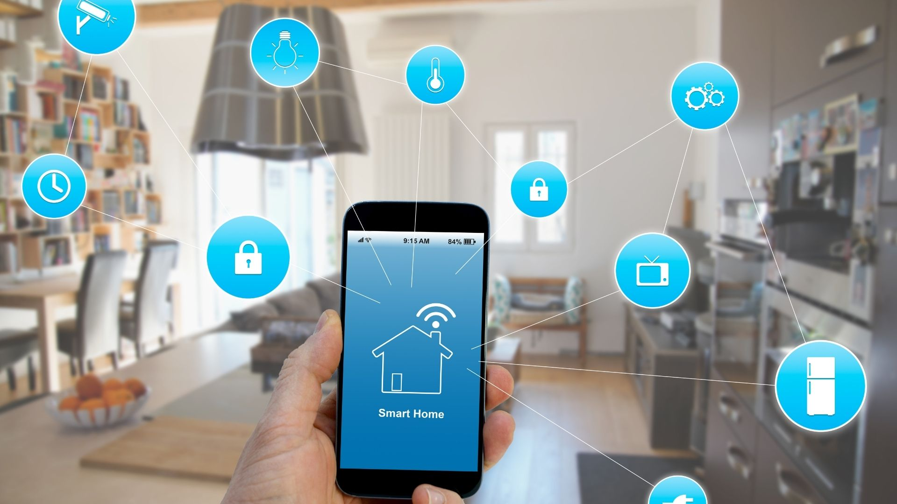

Figure 2.2: Remote control home.

2.3 Comparative Studies

Day by day the work and life of human beings are increasingly busy and complicated with the rapid growth in communications and information technology. As the economic expansion is growing rapidly, the standard of living also keeps on rising up and the people are requiring more living functions. The concept of smart home has focused the attention of re-searchers. A lot of efforts have been done for the development of home automation to control that remotely. Smart Home is an advanced technology to make a house to become intelligent and automated. Usually, that technology has automation systems for lighting, temperature control, security and many other functions. Here in this paper a comparative study has done on different types of home automation system. We have gone through different techniques for the implementation of smart home such as; phone-based remote controller for home and office automation, PC remote control of appliances by using telephone lines, Blue-tooth wireless technology based home automation, internet based wireless home automation system, remote home automation monitoring using mobile through spoken commands, GSM-based remote sensing and control system using FPGA, GSM-Bluetooth based remote monitoring and control system with automatic light controller .

2.4 Scope of the Problem

Home automation devices typically don't solve any problems by itself, because most of them are usually single purpose devices. However, when it comes to a home automation system that connects different devices and processes the data from each one, it's a different story.
Just having smart devices installed does not necessarily mean you've got a smart home. It's what you do with this system, what you teach and program it to do and it takes some efforts and creative thinking to get good results. Ability to use your cell phone to view camera footage, unlock your door or turn lights on/off are just some basic connected home features. Teaching your home to react and adjust based on your preference is where the true potential is.
A basic home automation solves many simple problems effectively, from saving energy easily, to removing the possibility of being locked out by losing a physical key, from checking if you had locked your door or turned that appliance off after you actually leave, to informing you about the foot traffic on your porch when you're not home, - you name it.
The true potential though is in discovering the problems that you may not even think are there and solving them for you with the help of Machine Learning.
Think about the enormous success of Nest thermostat. With programmable thermostats before Nest, a person first had to track their own habits for some time to later implement the rules for automating their climate control to fit their habits. That is a highly manual process! Nest learns by itself suggesting and implementing these rules on your behalf. Continuous optimization was not even a problem, you just kept your thermostat always on and heated/or cooled your house whether it was needed or not, wasting the energy and money.

2.5 Challenges

Manual thermostats, and dial-up connections that take too long to open a single email. With the available of reliable broadband connection, Wi-Fi-connected gadgets, and smartphones that house every app that you need to control just about any device, smart homes are now easier to build.
With this technology, you can turn on or off your lights in the house or close the garage door wherever you are in the world. All you need is open an app in your smartphone and click few buttons.
Although smart homes offer a number of benefits, they also present challenges. For them to be efficient, it is important that you have a highly reliable internet connection. If your Wi-Fi is down and you need to open the door to grant access to your kids, for example, while you are in the office, they might be sitting on the front lawn for quite some time. Also, smart homes are vulnerable to hackers who can hack into your gadgets and gather information that they can use to harm or extort money from you.
Further, these systems can be extremely expensive and learning how to use them could be a huge challenge, especially for older users who are not tech-savvy.

CHAPTER THREE: PROJECT MANAGEMENT

Home automation system is the basic automatic solution for daily home tasks such as adjusting temperature, opening and closing garage doors, central locking and other similar functions. Home automation is the combination of electronics and information technology and their application for controlling different tasks in the home. For the past few years, the development of new technologies and advancement in artificial intelligence made a simple automated home into a smart one.
The main purpose of the home automation system is to provide energy efficiency, security, and entertainment. Different devices are available in the market that can control the different part of home automation, some can provide entertainment, some can provide security and some can be energy efficient. The main problem with these devices is that they are unable to interact with each other effectually. Thanks for the advent of the Internet of things. Now smart home as the name suggests uses IOT as the basis for connecting with all the devices smartly. The advantage of wireless networking is providing flexibility, simplicity and cost efficiency.

3.1 CLIENT REQUIREMENTS AND CONSTRAINTS

In order to complete a project, meetings between clients and service providers are necessary. These meetings provide an understanding of the requirements and constraints of the client. In order to install the smart home automated system a total of four meetings are required with or without the client.
The first meeting will be with the client in order to understand his or her requirements. Requirements such as how many systems he wants to be automated. Are they want them to be centrally controlled? Or not. Should they be wireless or wire-based and what is their budget.
The second meeting will be with the team members of the project. This meeting will highlight the problem statement need of the client and how it can be achieved. The third meeting will be the final meeting with the client it will revolve around the discussion of risks and threats and negotiation if required. The fourth and the last meeting will be held between team members in order to plan different phase of the project.
In terms of customer requirement, following are some of them that are actually required by clients willing to install smart home automation.

Requirement | Description | Priority | Impact on Work
Compatibility of Devices | The device must be compatible with each other and other major products available in the market. | Very High | Have to buy products of the same brand and same vendor to ensure the compatibility
Easily Controllable | The system should be easily controllable, with central remote or with a smartphone app | High | Need to design a custom program while using API of devices used
Security  and Strength | The devices should be strong enough against any damage as well as against any technological breach | Very High | Does not impact so much as the security and strength have already been considered in previous requirements

3.2 STAKEHOLDER PERSPECTIVES

Other stakeholders in this project are neighbors, team workers, vendors form the products will be purchased. Their perspective also matters besides the client. A summary of views of other stakeholders on the requirements of the client are as follows

Client Requirement | Worker View | Vendor View
Compatibility of Devices | Will feel bad because they have to search and locate devices with compatibility | View this as a revenue generator option, because the same brand devices will be purchased.
Easily Controllable | Have to develop a system of integration | Need to provide the latest models of devices
Security and Strength | Have to provide security, double check each thing. Helpful in getting recommendations. | Provide high-quality devices making more profit for them

3.3 WORK BREAKDOWN STRUCTURE (WBS) AND WBS DICTIONARY

The work breakdown structure of the project is as follows:
- Start of the Project
- Client meeting for asking requirements
- Meeting with team members to check the feasibility of the project
- Client meeting for discussing risk and threats associated with the project
- Planning
- Studying the project
- Meeting with team members to understand implementations
- Developing blueprints
- Searching and locating vendors
- Developing
- Buying compatible devices
- Integrating them with each other
- Developing a central control system
- Testing for any vulnerabilities
- Implementation
- Installation of devices
- Adjusting the system to the real world
- Final testing
- Training and Handling Over
- Training client
- Handling over of security information (keys/password)
- Describing polices
- Finalizing Project
- Final report
- Closing of project

WBS Component | Description
Start of Project | This process will majorly consist of meetings with the client in order to understand the basic need and requirements of the client
Planning | The planning phase is the development of blueprints as well as the selection of devices to be used
Developing | The developing phase will be revolving around the buying and integrating of home automated devices. This phase also incorporates the development of a central control system, i.e. software for smartphone
Implementation | Installation of the developed system at the actual location
Training and Handling Over | Providing training to the client for how to use and handing over of the system
Finalizing Project | Preparation of the final report for further study

3.4 TIME MANAGEMENT

The time span of this project will be for three months. This 90-days long period is required, in order to maintain the quality of the project. A Gantt chart for this project is as follows:

Month  1 | Month 2 | Month 3
W1 | W2 | W3 | W4 | W1 | W2 | W3 | W4 | W1 | W2 | W3 | W4
Start
Planning
Developing
Implementation
Training
Finalizing

3.5 COST MANAGEMENT

Cost management is also an integral part of any project. For this project, the total cost depends on the resources used, especially the quality and compatibility of the devices. The cost of the project can be maintained by using open source software and frameworks for establishing the control app or system. The use of electronic devices such as Raspberry Pi and Arduino can also be beneficial in managing the cost of the project. An estimated cost plan for the project is given below:

Id | Item | Description | Estimated Cost
1 | Devices for Home Automation | Multiple devices such as thermostat, central locking, energy saver, light controller etc. | 8000Tk
2 | Devices for Central Control | Arduino, Wi-Fi controller, wireless modem | 5000Tk
3 | Central Software Development | Development of application for centrally controlling all the devices | 2000Tk
4 | Installation Charges | Installation and labor charges | 1000Tk
Total | 16,000Tk

CHAPTER FOUR: TECHNICAL SPECIFICATIONS

The design of smart home system is based on what all devices we want to automate. Smart home includes automation of light, bulb, fan, refrigerator, geyser and security of home by means of fire notify, presence monitor etc.
Once the user needs are recorded, it is easy to design the system. Based on this what type of protocols to be used and what all sensors are required is calculated. The basic requirement in a smart home system is the combination of certain hardware and software. The interface and the communication protocol between the hardware and software to send notification to the user.

4.1 System Perspective

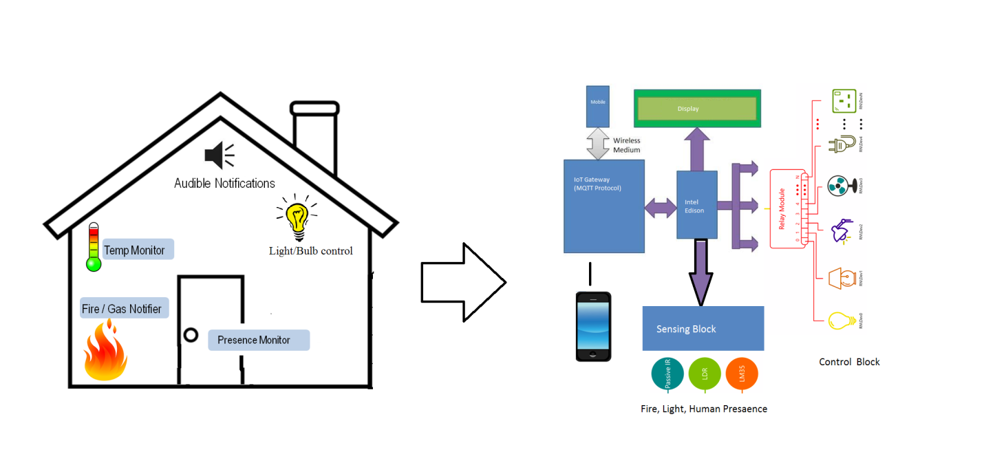
Figure 4.1: Block diagram

We are developing a smart home system where we can control the light and fan based on my mobile also I want to implement a fire alarm system such that in my absence it can notify me if there is a fire in my home in that case I can build a controller which I can control through mobile. I can have a fire alarm system which can put some buzzle but I cannot combine them into single internet architecture with present system.

Therefore, we are proposing an IoT based smart home system. We are going to connect one light and one fan with this device to start it. We should be able to control both the lights and fan through our mobile. This whole thing should have a location awareness that means when we come closer to our home we could turn on the light and when we go away from home the light could be turned off.

We are going to put a security system for example we are going to put a fire alarm system whenever there is a fire at home it is going to respond to our mobile. In case our mobile numbers are in silent mode if there is a fire at home not always we are going to see the alarms. Through IoT system we are going to put the same data to our Gmail account and tweeter account so that even if we are not aware that our home has got fire someone from our friend or someone from twitter followers would be aware that there is a fire and could take appropriate action.

Basically we are doing a security system with fire, a physical world system with light and bulb control. A security system if there is an intruder in home. We are also going to control them with mobile interface. We are also going to control them through our location awareness.

4.2 Modules:

- LCD Display
This module takes the input from the sensor and displays the message on the screen.

- Fire Notifies
It takes the input from the temperature sensors and checks if the temperature is higher than the normal, it notifies the user by sending the alert message.

- Presence Monitor
This module checks whether there is any intruder at home, it checks the mike value by a sound sensor. If the mike value is higher than the normal, then it generates the alert message to the user and also it displays on the LCD screen.

- Light/ Bulb Control
This module is based on the commands given by the user. The light gets turned on when the user gives the ON command and gets turned off when given an OFF command. The commands are given in the form of message by using the MQTT protocol.

- Sensors

Sensor takes input from the environmental changes. Such as temperature sensors, light sensor, sound sensor etc. After taking the input it sends the data to the LCD screen and to the Intel device.

4.3 Context Diagram:

Level: 0
Figure: Level Zero DFD

Level: 1
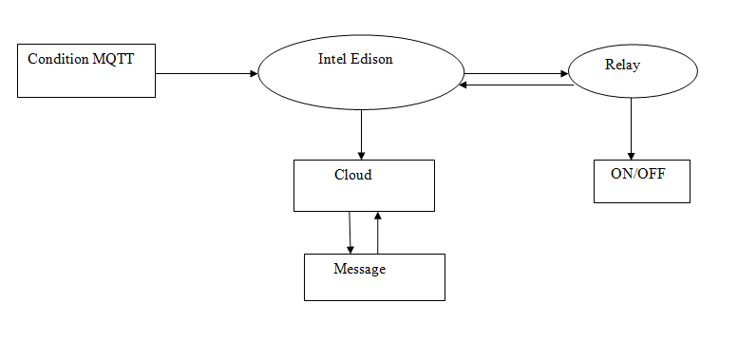
Figure: Level One DFD
Level: 2

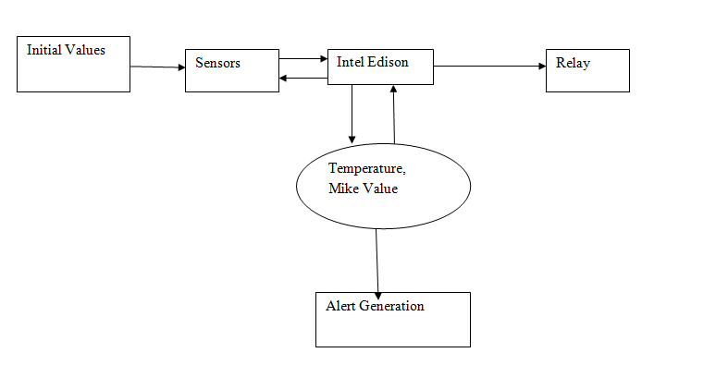
Figure: Level Two DFD

4.4 Use Case Diagrams:
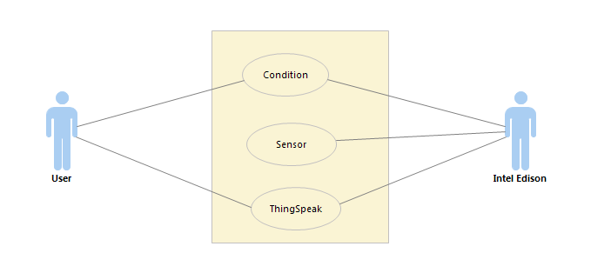
Figure 4.4: Use Case Diagram

4.5 Sequence Diagrams:

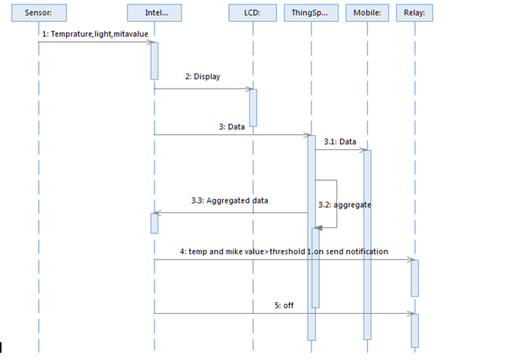

Figure 4.5: Sequence Diagram

4.6 Collaboration Diagrams:

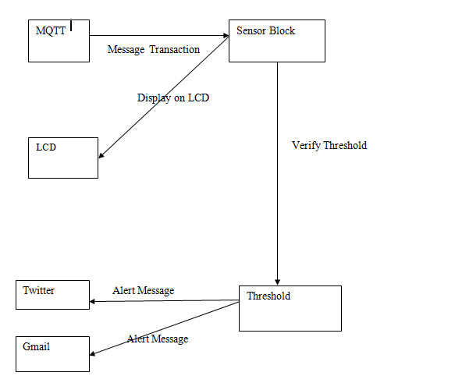

Figure 4.6: Collaboration Diagram

4.7 Activity Diagrams:

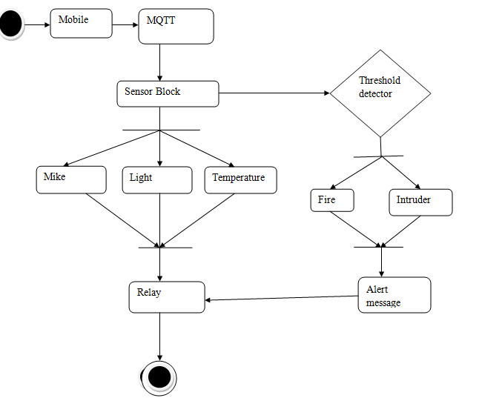

Figure 4.7: Activity Diagram

4.8 ER Diagram:
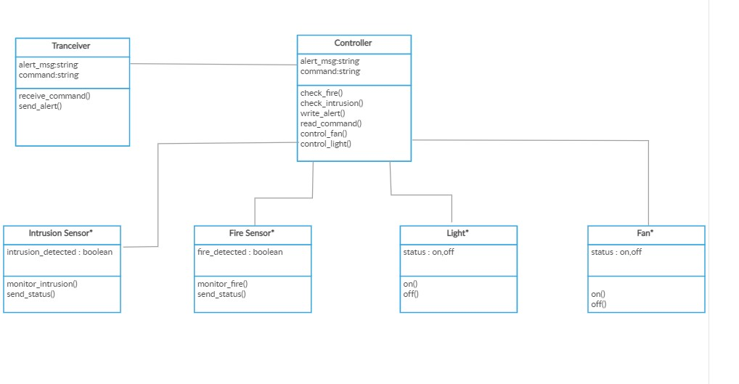
Figure 4.8: ER Diagram

CHAPTER FIVE: RISK MANAGEMENT

5.1 Stay Safe

Smart homes use internet-connected devices, such as light switches and fridges, that can autonomously flick on your lights, open doors, or even alert you when you’re running low on milk. But all this convenience and connectivity come at a price. Namely, smart-home devices are prone to a plethora of security vulnerabilities that can put your data or property at risk if you’re not careful. Ahead are the scariest threats posed by your smart-home devices—and how to mitigate them.
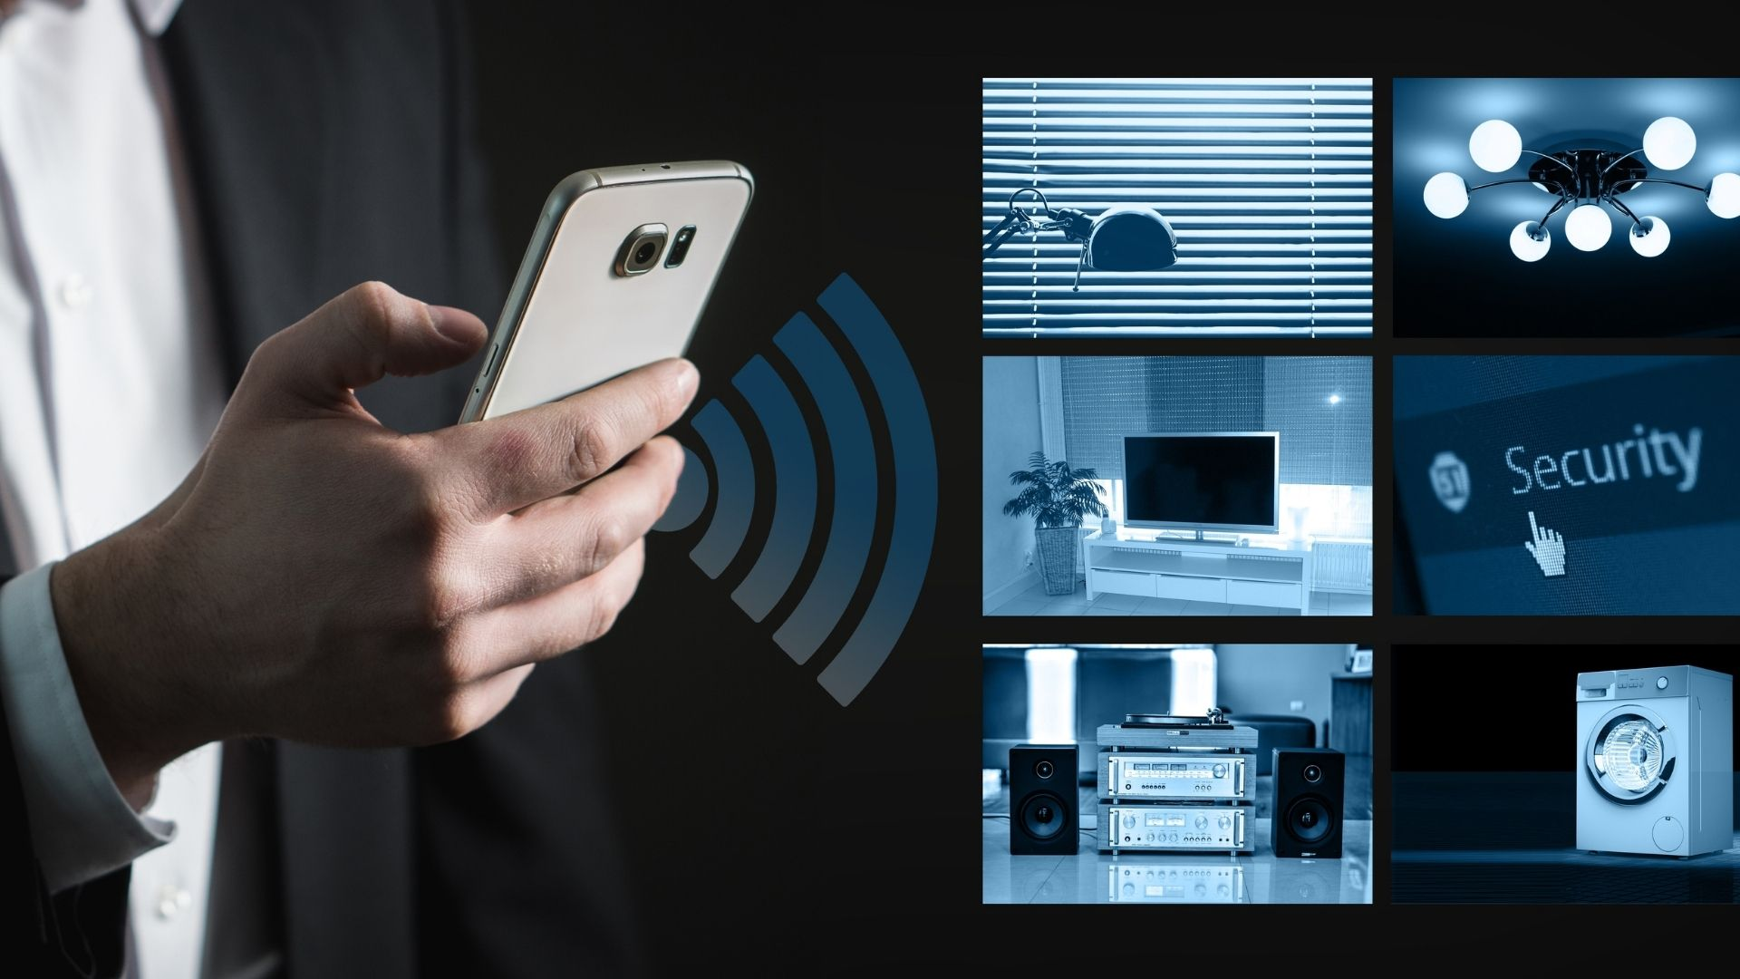

Figure 5.1: Stay Safe

5.2 Targeted Attacks

Smart-home devices hold a treasure trove of personal information, from your birth date to credit card details, that cybercriminals can steal via hacking if the devices lack robust protections to thwart attacks. They can then use the stolen data to launch targeted attacks to rope you into shady deals. For example, if a hacker were to uncover that one of your family members has debts, he could send you a phony request for money on behalf of that relative. To avoid becoming a cyber-victim, don’t share financial information, such as bank details, with smart devices, and avoid connecting email clients, calendars, and other apps that contain sensitive information with your devices.

5.3 Identity Theft

In some instances, instead of breaching a single individual’s smart device to nab his data, a hacker will infiltrate the database of a smart-device company to pilfer the data of all its users. Massive data breaches can expose the data of hordes of users of certain smart devices. If you're one of those unfortunate users, a digital thief can apply for credit cards using your name, take out a mortgage under your name, or otherwise impersonate you and turn your life upside down. You can reduce the risk of a data breach affecting you by sharing minimal personal information with smart devices and regularly monitoring your credit report for negative changes.

5.4 Password Exploitation

Too often, smart-home hubs that connect all the smart devices on your network are secured with a weak password. This security lapse allows clever hackers to easily penetrate and gain access to the hub and tamper with it and other smart devices in your home; for example, hackers could spook homeowners by switching lights on and off or changing TV channels. To avoid virtual break-ins, always establish complex, unique passwords and use two levels of authentication for all your smart devices.

5.5 Location Tracking

You trust your smart-home devices to keep your private information private, particularly information about where you live. But these devices can betray that trust by giving away your location and making it possible for hackers to find you and spy on you in real time. For example, clicking on a malicious link through a smartphone or computer has in the past duped vulnerable smart speakers into revealing a user’s location right down to the street address when the phone or computer was connected to the same network. Avoiding suspicious links and maintaining a second network just for smart-home devices can help keep your coordinates a secret.

5.6 RISK MANAGEMENT:

Following are some of the key risks and threats found to be associated with the project planning:

Id | Risk | Mitigation | Chances | Severity
1 | Selecting inappropriate devices, reduce compatibility | Proper research and review before purchasing any item.  Buy established brand | High | High
2 | Lack of security consideration may arise security threats | Check everything twice before finalizing.  Follow industry standards | High | Very High
3 | Ineffective project management resulting in increased time and cost | Proper planning, with constant meeting and communication with stakeholders | Medium | Medium
4 | Lack of training and early support | Provide in-depth training and education before finalizing the project | Low | Low
5 | After project complains and queries regarding warranties | Provide proper policy and terms and condition document before winding up the project | Low | Low

CHAPTER SIX: CONCLUSION

Smart Home System has been one of the popular areas of automation and embedded electronics, over past several decades we have used various different techniques for generating alarm, security and automating the home devices it includes usage of radio technology such as IR devices, RC devices, etc.

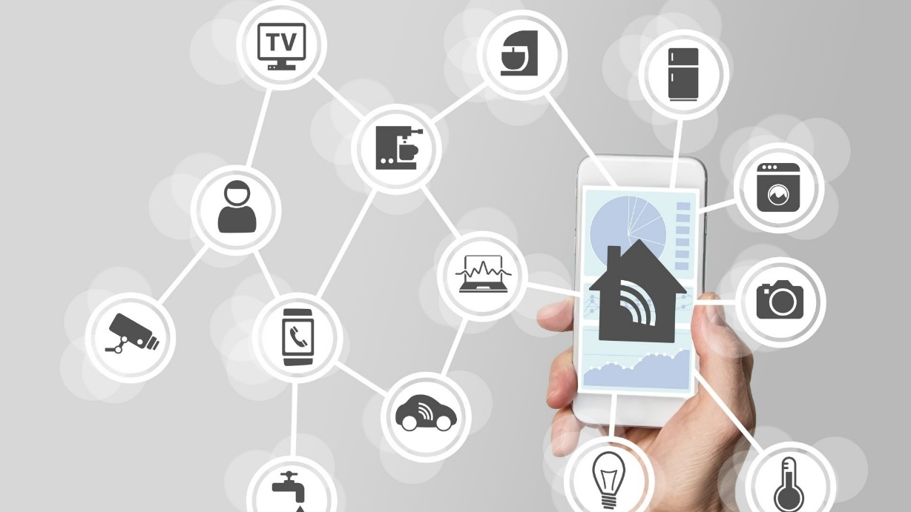

Figure: Home Automation System

Smart Home System also has several other components like safety and security, many safety devices like fire alarm device and automatic fire extinguisher is been proposed in the past. Most of the existing alarm systems are based on GSM and GPRS based techniques which are slow in latency as well as quite expensive as the messages and voice mail are not free, in this work we have proposed a novel architecture to offer safety, and automation of the home over IoT architecture.
The proposed system can alert the user in case home catches fire or in case there is an intruder at home, when he is absent. The system also allows the user to operate his home devices purely through his mobile. The entire control and notification system is based on IoT infrastructure, MQTT as well as Gmail and twitter are free sites and it can operate over the Wi-Fi data, this significantly reduces cost as SMS and GPRS are not been used over here.
The result shows that the proposed system meets the objective and can respond to fire, intruder with bare minimum latency and can mitigate the alert to multiple channel simultaneously.

This work can be further improved by incorporating other home automation concepts such as home security through face recognition and other advanced machine learning techniques. The framework can also be improved by incorporating the control of other home devices such as air conditioner, washing machine etc.

